Krzysztof Koch
COMP32211
Ex2 and Ex3 submission
26.11.2016

Ex2
Source code:

mandelbrot_logic.v

/****************************************************************************************
* Author: Krzysztof Koch
* Brief: Mandelbrot set combinatorial logic
* Date created: 18/11/2016
* Last edit: 25/11/2016
*
* Note:
* Logic to determine whether the complex function z_(n+1) = (z_n)^2 + C diverges for
* given'z' and 'c' and to compute the next 'z' in this recurrence equation
****************************************************************************************/

/*--------------------------------------------------------------------------------------
* Constant parameters
*-------------------------------------------------------------------------------------*/
`define Q_LEN 50 // Number of bits for representing complex numbers
// using signed fixed point numbers
`define FRAC_LEN 44 // Bits in the fractional part
`define INT_LEN `Q_LEN-`FRAC_LEN // Bits in the integer part (including sign bit)
`define PRE_MUL_SHIFT `FRAC_LEN/2 // Shift before fixed-point multiplication
`define MANDEL_INFINITY 4 // Mandebrot definiton of 'infinity'

/*--------------------------------------------------------------------------------------
* Module declaration
*-------------------------------------------------------------------------------------*/
module mandelbrot_logic (input wire [`Q_LEN-1:0] z_real, // Real part of 'z_n'
input wire [`Q_LEN-1:0] z_imag, // Imaginary part of 'z_n'
input wire [`Q_LEN-1:0] c_real, // Real part of 'C'
input wire [`Q_LEN-1:0] c_imag, // Imaginary part of 'C'
output reg [`Q_LEN-1:0] next_z_real, // Real part of 'z_(n+1)'
output reg [`Q_LEN-1:0] next_z_imag, // Imaginary part of 'z_(n+1)'
output reg finished); // 'Function diverges' flag

/*--------------------------------------------------------------------------------------
* Internal signals and buses used. All buses carry numbers in the Q(INT_LEN.FRAC_LEN) format
*-------------------------------------------------------------------------------------*/
reg [`Q_LEN -1:0] bound; // Mandelbrot 'infinity'
reg [`Q_LEN -1:0] mul_op1; // Multiplication operands: complex number
reg [`Q_LEN -1:0] mul_op2; // values "shifted" right for fixed-point multiplication
reg [`Q_LEN -1:0] z_real_sq; // Squared values of real and imaginary part of complex
reg [`Q_LEN -1:0] z_imag_sq; // number 'z'
reg [`Q_LEN -1:0] func_val; // z^2 - used to check if function goes to infinity

/*--------------------------------------------------------------------------------------
* Determine if, for current value of 'z' and 'c' the resulting value of function
* 'z^2' + c is bounded. Also the next value of 'z' is computed
*-------------------------------------------------------------------------------------*/
always @ (*)
begin
// Calculate the bound as a fixed-point fractional number
bound = `MANDEL_INFINITY << `FRAC_LEN;

// Signed shift of both real and imaginary parts of 'z'. Necessary to fit multiplication
// output inside registers of same size as inputs
if (z_real[`Q_LEN-1])
mul_op1 = {{`PRE_MUL_SHIFT{1'b1}}, z_real[`Q_LEN -1:`PRE_MUL_SHIFT]};
else
mul_op1 = {{`PRE_MUL_SHIFT{1'b0}}, z_real[`Q_LEN -1:`PRE_MUL_SHIFT]};

if (z_imag[`Q_LEN-1])
mul_op2 = {{`PRE_MUL_SHIFT{1'b1}}, z_imag[`Q_LEN -1:`PRE_MUL_SHIFT]};
else
mul_op2 = {{`PRE_MUL_SHIFT{1'b0}}, z_imag[`Q_LEN -1:`PRE_MUL_SHIFT]};

// Calculate the squared value of real an imaginary part of 'z'
z_real_sq = mul_op1 * mul_op1;
z_imag_sq = mul_op2 * mul_op2;

// Calculate the next value of 'z'
next_z_real = z_real_sq - z_imag_sq + c_real;
next_z_imag = ((mul_op1 * mul_op2) << 1) + c_imag;

// Determine whether the recurrence function diverges ('z' lies outside circle of
// of radius 2)
func_val = z_real_sq + z_imag_sq;
finished = (func_val > bound) ? 1 : 0;
end

endmodule

drawing_mandelbrot.v

/*******************************************************************************************
* Author: Krzysztof Koch
* Brief: Mandelbrot set visualisation drawing module
* Date created: 17/11/2016
* Last edit: 26/11/2016
*
* Note:
* "The" Mandelbrot set is the set obtained from the quadratic recurrence equation
* (z_n+1) = (z_n)^2 + C with z_0 = C, where points 'C' in the complex plane for which
* the orbit of 'z_n' does not tend to infinity are in the set.
*
* Given:
* r0 - maximum number of iterations before mandelbrot set membership is determined
* r1 - 'C_0' (real)
* r2 - 'C_0' (imaginary)
* r3 - step size in Argand plane
* Each pixel coordinate on VGA screen (640x480) is mapped to a point in Argand plane 'C'.
* Then the recurrence equation is applied at most r0 times. The computation of single pixel
* colour can terminate sooner if 'z_n' lies outside a circle of radius 2, which guarantees
* the function will diverge.
*
* Optimisations introduced are:
* 1. Calulation of pixel colour starts with z_1 = C. so that one cycle is saved instead
* of doing z_0 = 0 in the function (z_n+1) = (z_n)^2 + C
* 2. At least two cycles are needed to compute a pixel value and send the respective value
* in the drawing interface. Some pipelining is introduced by sending the command while the
* computation of next pixel is started.
*******************************************************************************************/

/*------------------------------------------------------------------------------------------
* Definitions
*-----------------------------------------------------------------------------------------*/
// FSM states
`define IDLE 0 // Device is idle
`define NEW_PIXEL 1 // Compute new pixel value
`define CONTINUE_PIXEL 2 // Computation of pixel current pixel value in progress

// Global constants
`define Q_LEN 50 // Size of registers holding complex numbers
`define FRAC_LEN 44 // Number of bits for the fractional part
`define INT_LEN `Q_LEN-`FRAC_LEN // Number of bits for the integer part
`define INPUT_LEN 16 // Input parameter size (in bits).
`define INPUT_INT_LEN 4 // Number of bits for integer and fractional part of r1, r2
`define INPUT_FRAC_LEN `INPUT_LEN-`INPUT_INT_LEN

`define STEP_SIZE_SHIFT 4 // Shift for conversion of step size (for better zoom)

/*******************************************************************************************
* Module declaration
*******************************************************************************************/
module drawing_mandelbrot (input wire clk, // Master clock
input wire req, // Command request
output reg ack, // Acknowledge command request
output wire busy, // Drawing module busy
input wire [15:0] r0, // Maximum number of iterations per pixel
input wire [15:0] r1, // Starting Real coordinate in Argand plane
input wire [15:0] r2, // Starting Imaginary coordinate in Argand plane
input wire [15:0] r3, // Step size in Argand space (32bit)
input wire [15:0] r4, // Step size in Argand space (32bit)
input wire [15:0] r5, // Screen width (in pixels)
input wire [15:0] r6, // Screen height (in pixels)
input wire [15:0] r7, // not used
output wire de_req, // Drawing request
input wire de_ack, // Acknowledge drawing request
output wire [17:0] de_addr, // Word address of pixel to draw
output reg [3:0] de_nbyte, // Byte number of pixel to draw
output wire [31:0] de_data); // Pixel value

/*------------------------------------------------------------------------------------------
* Internal registers
*-----------------------------------------------------------------------------------------*/
reg [1:0] draw_state; // Current state of the Mandelbrot drawing FSM
reg [15:0] max_iterations; // Max iterations before Mandelbrot set membership determined
reg [15:0] iteration; // Iteration counter
reg [`Q_LEN-1:0] init_c_r; // Initial value of real part of 'c'
reg [`Q_LEN-1:0] z_r; // Current real part of 'z'
reg [`Q_LEN-1:0] z_i; // Current imaginary part of 'z'
reg [`Q_LEN-1:0] c_r; // Current real part of 'c'
reg [`Q_LEN-1:0] c_i; // Current imaginary part of 'c'
reg [`Q_LEN-1:0] argand_step; // Step size in Argand plane
reg [9:0] screen_width; // Screen size
reg [9:0] screen_height;
reg [9:0] x_pos; // Current X coordinate of pixel computed
reg [9:0] y_pos; // Current Y coordinate of pixel computed

/*------------------------------------------------------------------------------------------
* Internal signals and buses
*-----------------------------------------------------------------------------------------*/
wire finished; // 1 if recurring function diverges
wire [`Q_LEN-1:0] next_z_r; // Next real value of 'z'
wire [`Q_LEN-1:0] next_z_i; // Next imaginary value of 'z'
wire [`Q_LEN-1:0] start_real; // Starting point in argand plane (real and imaginary part).
wire [`Q_LEN-1:0] start_imag; // and step size in argand plane converted to internal complex
wire [`Q_LEN-1:0] step; // number representation
wire [19:0] address; // Pixel address in frame store

/*------------------------------------------------------------------------------------------
* Initialise the combinatorial logic module for Mandelbrot set calculation
*-----------------------------------------------------------------------------------------*/
mandelbrot_logic logic( .z_real(z_r),
.z_imag(z_i),
.c_real(c_r),
.c_imag(c_i),
.next_z_real(next_z_r),
.next_z_imag(next_z_i),
.finished(finished));

/*------------------------------------------------------------------------------------------
* Assign starting values of some of the outputs
*-----------------------------------------------------------------------------------------*/
initial draw_state = `IDLE; // Starting state
initial ack = 0; // Starting value of ack

/*------------------------------------------------------------------------------------------
* Simple output combinatorial logic
*-----------------------------------------------------------------------------------------*/
// Device is always busy unless in the idle state
assign busy = draw_state != `IDLE;

// Insert de_req when the pixel value computation is finished, de_ack is cleared and the
// module is actually processing a request
assign de_req = busy && (finished || (iteration >= max_iterations));

// Convert the input parameters Q4.12 to Q6.44
assign start_real = {{(`INT_LEN-`INPUT_INT_LEN){r1[`INPUT_LEN-1]}}, r1, {(`FRAC_LEN-`INPUT_FRAC_LEN+8){1'b0}}};
assign start_imag = {{(`INT_LEN-`INPUT_INT_LEN){r2[`INPUT_LEN-1]}}, r2, {(`FRAC_LEN-`INPUT_FRAC_LEN+8){1'b0}}};

// Convert the step size from Q0.32 to Q6.44
assign step = {{`INT_LEN{1'b0}}, r3, r4, {(`FRAC_LEN-2*`INPUT_LEN){1'b0}}};

// Pixel value to write. Inside of the fractal is black. Colour is 8bit RGB so is
// repeated fo match the word size in memory
assign de_data = iteration == max_iterations ? 0 : {4{iteration[7:0]}};

// Calculate pixel address in the frame store based on current x and y position
assign address = (y_pos << 9) + (y_pos << 7) + x_pos;
assign de_addr = address[19:2];

// Decode the lower 2 bits of address to produce nbyte selects.
always @(address[1:0])
case(address[1:0])
2'b00 : de_nbyte <= 4'b1110;
2'b01 : de_nbyte <= 4'b1101;
2'b10 : de_nbyte <= 4'b1011;
2'b11 : de_nbyte <= 4'b0111;
default:de_nbyte <= 4'b1111;
endcase

/*******************************************************************************************
* FSM
*******************************************************************************************/
always @ (posedge clk)
begin
case (draw_state)

/*----------------------------------------------------------------------------------
* Idle state, device is waiting for a request
*---------------------------------------------------------------------------------*/
`IDLE:
// If a request arrives...
if (req)
begin
// Load the input parameters from command interface
max_iterations <= r0;
init_c_r <= start_real;
c_r <= start_real; // One mandelbrot iteration is saved by
z_r <= start_real; // setting 'z' directly to 'c' instead of 0
c_i <= start_imag; // This is why iteration counter is reset to 1
z_i <= start_imag;
argand_step <= step;
screen_width <= r5;
screen_height <= r6;

// Reset value of other registers
ack <= 1; // Acknowledge the request
iteration <= 1; // Reset the iteration counter
x_pos <= 0; // Start with the top left pixel
y_pos <= 0;
draw_state <= `CONTINUE_PIXEL; // Carry on with calculation of the first pixel
end // This saves a cycle, instead of goint to `NEW PIXEL

/*----------------------------------------------------------------------------------
* New pixel value to compute
*---------------------------------------------------------------------------------*/
`NEW_PIXEL:
begin
// Clear 'acknowledge' output signal in command interface and Reset the iteration counter
ack <= 0;

// Wait for acknowledgement from memory to carry on with computing next pixel
if (de_ack)
begin
iteration <= 1;

// If the last pixel in a row has been computed
if (x_pos + 1 >= screen_width)
begin
// If both the pixel X and Y coordinate have 'overflowed' then the request has been
// completed
if (y_pos + 1 >= screen_height)
draw_state <= `IDLE;

// Go to the row below to avoid going off screen. Update both the pixel coordinates
// and Argand plane coordinates and set the next state to continue calculation
else
begin
x_pos <= 0;
y_pos <= y_pos + 1;
c_r <= init_c_r;
z_r <= init_c_r;
c_i <= c_i + argand_step;
z_i <= c_i + argand_step;
draw_state <= `CONTINUE_PIXEL;
end
end
// Simplest case, next pixel to compute is to the right of the previous one
else
begin
x_pos <= x_pos + 1;
c_r <= c_r + argand_step;
z_r <= c_r + argand_step;
z_i <= c_i;
draw_state <= `CONTINUE_PIXEL;
end
end
end

/*----------------------------------------------------------------------------------
* Pixel value still computed (Mandelbrot set membership is not determined)
*---------------------------------------------------------------------------------*/
`CONTINUE_PIXEL:
begin
// Clear 'acknowledge' output signal in command interface
ack <= 0;

// If either the 'z' value has overflown or max number of iterations is reached
// computation is over.
if (finished || iteration >= max_iterations)
draw_state <= `NEW_PIXEL;

// Update current 'Z' and increment the iteration counter
else
begin
iteration <= iteration + 1;
z_r <= next_z_r;
z_i <= next_z_i;
end
end
default: draw_state <= `IDLE;
endcase
end
endmodule

Tests:

mandelbrot_logic_test.v

/****************************************************************************************
* Author: Krzysztof Koch
* Brief: Test fixture for mandelbrot_logic.v
* Date created: 18/11/2016
* Last edit: 25/11/2016
*
* Note: Functional test of internal combinatorial logic for determining
****************************************************************************************/

/*---------------------------------------------------------------------------------------
* Definitions
*--------------------------------------------------------------------------------------*/
`define Q_LEN 50 // Size of registers holding complex numbers
`define TIME_DELAY 5 // Delay between sucessive tests
`define TEST_VECTORS_NO 19 // Number of test vectors
`define MAX_ITER_VEC_NO 3 // Number of different iteration limits

/*---------------------------------------------------------------------------------------
* Global variables
*--------------------------------------------------------------------------------------*/
integer iteration; // number of iterations for mandelbrot set
integer real_index; // index into c_real_in
integer imag_index; // index into c_imag_in
integer iter_limits_index; // index into iter_limits

// Test cases
reg [`Q_LEN-1:0] c_real_in [0:`TEST_VECTORS_NO];
reg [`Q_LEN-1:0] c_imag_in [0:`TEST_VECTORS_NO];
reg [9:0] iter_limits[0:`MAX_ITER_VEC_NO];

/*---------------------------------------------------------------------------------------
* Test bench
*--------------------------------------------------------------------------------------*/
initial
begin

// Initialise iteration limits
iter_limits[0] = 20;
iter_limits[1] = 1;
iter_limits[2] = 1000;

// Initialise test cases, all values are Q(6.44). Sign bit included in the integer part
c_real_in[0] = 0; // 0.0
c_real_in[1] = `Q_LEN'h000000A700000; // 0.00001
c_real_in[2] = `Q_LEN'h0019999999999; // 0.1
c_real_in[3] = `Q_LEN'h004CCCCCCCCCC; // 0.3
c_real_in[4] = `Q_LEN'h0080000000000; // 0.5
c_real_in[5] = `Q_LEN'h0099999999999; // 0.6
c_real_in[6] = `Q_LEN'h001C7A3900000; // 0.11124
c_real_in[7] = `Q_LEN'h00DF765F00000; // 0.872
c_real_in[8] = `Q_LEN'h0100000000000; // 1.0
c_real_in[9] = `Q_LEN'h3FDF765F00000; // -0.128
c_real_in[10] = `Q_LEN'h3FB3333333333; // -0.3
c_real_in[11] = `Q_LEN'h3F00000000000; // -1.0
c_real_in[12] = `Q_LEN'h3E1C7A3900000; // -1.88876
c_real_in[13] = `Q_LEN'h0000000000000; // smallest positive number possible
c_real_in[14] = `Q_LEN'h3FFFFFFFFFFFF; // largest negative number possible
c_real_in[15] = `Q_LEN'h1F00000000000; // largest positive number possible
c_real_in[16] = `Q_LEN'h2000000000000; // smallest negative number
c_real_in[17] = `Q_LEN'h333333CCCCCCC; // weird bit-patterns
c_real_in[18] = `Q_LEN'h0F0F0F0F0F0F0;

c_imag_in[0] = 0; // 0.0i
c_imag_in[1] = `Q_LEN'h000000A700000; // 0.00001i
c_imag_in[2] = `Q_LEN'h0019999999999; // 0.1i
c_imag_in[3] = `Q_LEN'h004CCCCCCCCCC; // 0.3i
c_imag_in[4] = `Q_LEN'h0080000000000; // 0.5i
c_imag_in[5] = `Q_LEN'h0099999999999; // 0.6i
c_imag_in[6] = `Q_LEN'h001C7A3900000; // 0.11124i
c_imag_in[7] = `Q_LEN'h00DF765F00000; // 0.872i
c_imag_in[8] = `Q_LEN'h0100000000000; // 1.0i
c_imag_in[9] = `Q_LEN'h3FDF765F00000; // -0.128i
c_imag_in[10] = `Q_LEN'h3FB3333333333; // -0.3i
c_imag_in[11] = `Q_LEN'h3F00000000000; // -1.0i
c_imag_in[12] = `Q_LEN'h3E1C7A3900000; // -1.88876i
c_imag_in[13] = `Q_LEN'h0000000000000; // smallest positive number possible
c_imag_in[14] = `Q_LEN'h3FFFFFFFFFFFF; // largest negative number possible
c_imag_in[15] = `Q_LEN'h1F00000000000; // largest positive number possible
c_imag_in[16] = `Q_LEN'h2000000000000; // smallest negative number
c_imag_in[17] = `Q_LEN'h333333CCCCCCC; // weird bit-patterns
c_imag_in[18] = `Q_LEN'h0F0F0F0F0F0F0;

// Go through all possible iteration limits
for (iter_limits_index = 0; iter_limits_index < `MAX_ITER_VEC_NO; iter_limits_index = iter_limits_index + 1)
begin
// Go through each value of z (both imaginary and real part). Reset Z complex number
// on each test case as well as the iteration counter
for (real_index = 0; real_index < `TEST_VECTORS_NO; real_index = real_index + 1)
begin
c_real = c_real_in[real_index];
for (imag_index = 0; imag_index < `TEST_VECTORS_NO; imag_index = imag_index + 1)
begin
c_imag = c_imag_in[imag_index];
z_real = 0;
z_imag = 0;
iteration = 0;
#`TIME_DELAY

// Count the number of iterations needed to determine mandelbrot set membership
// There is a cap in order to avoid looping infinitely
while ((iteration < iter_limits[iter_limits_index]) && ~finished)
begin
#`TIME_DELAY
iteration = iteration + 1;
z_real = next_z_real;
z_imag = next_z_imag;
end
end
end
end
$stop;
end

testVectors.v

1. 15 E000 F000 0147 0000 640 480
2. 20 F400 0199 0080 0000 640 480
3. 37 F400 0199 0020 0000 640 480
4. 100 F400 0199 0000 2000 640 480
5. 201 0540 0100 0004 0000 640 480
6. 70 0500 07B6 0002 0000 640 480
7. 60 E400 0000 0000 4000 640 480
// End of “nice” tests that are shown on diagrams below in order

8. 10 E000 F000 00FF FFFF 10 480
9. 2 8000 7FFF 0000 0001 20 20
10. 1 0000 0000 832D A7B1 1280 720

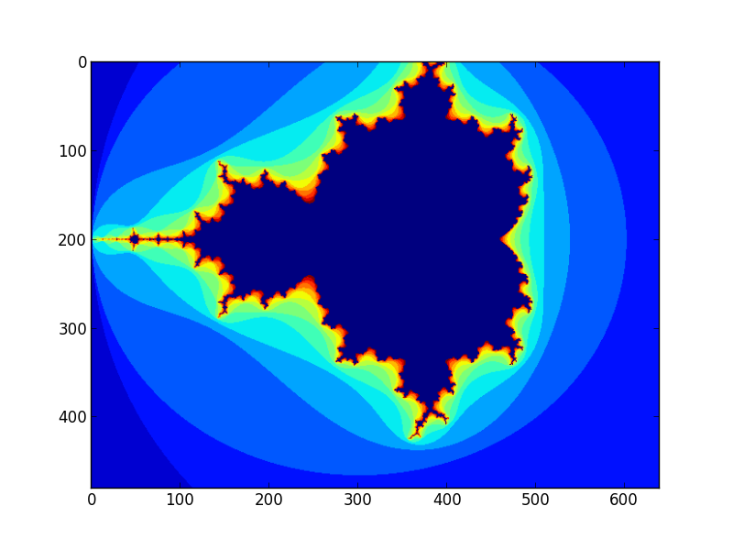
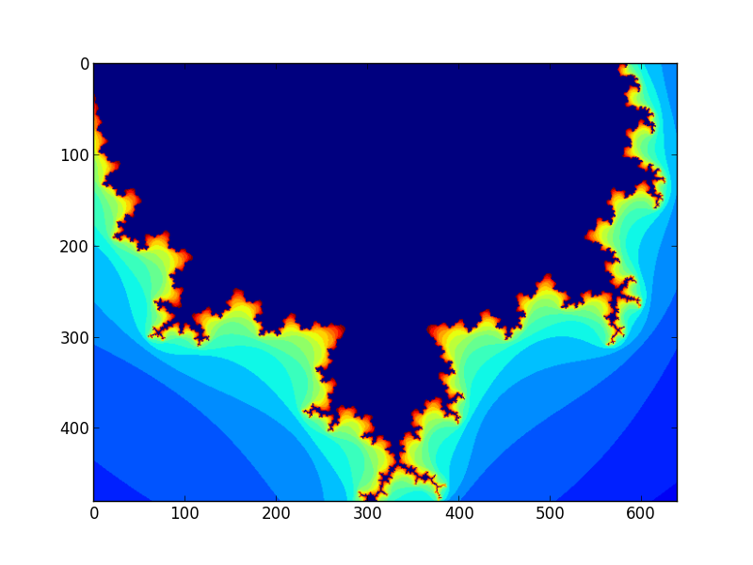

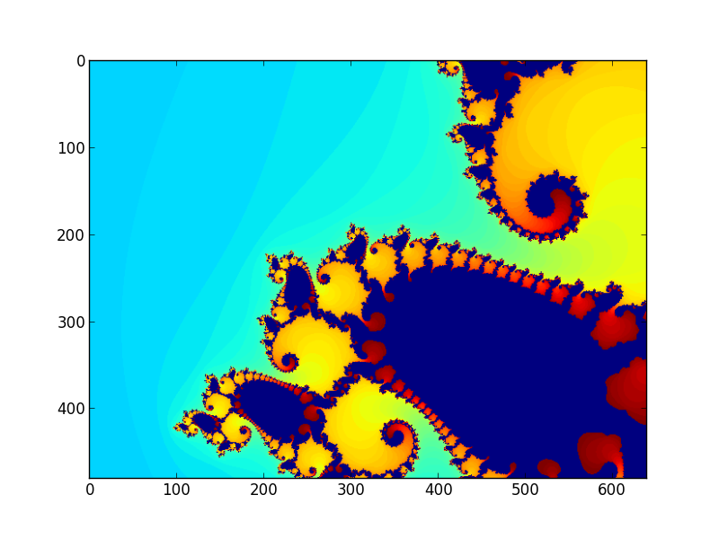
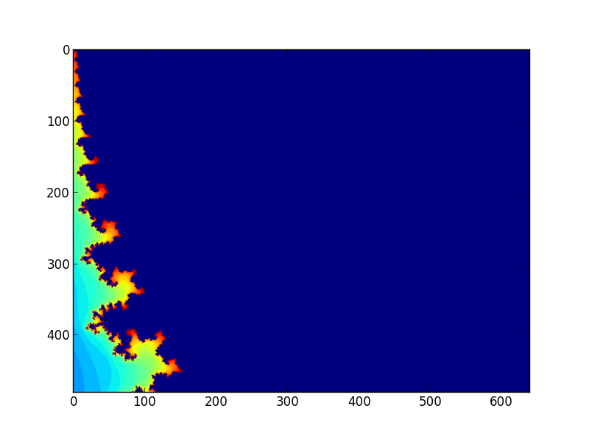

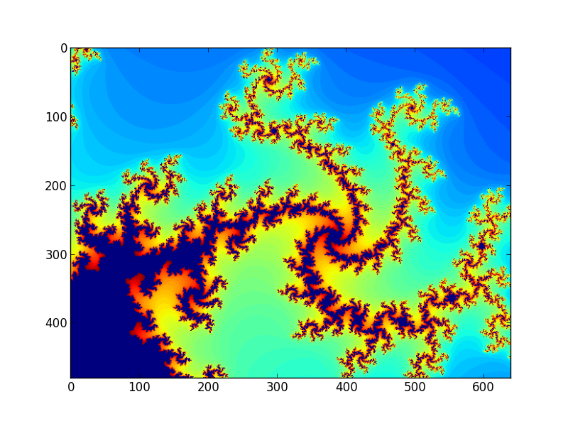
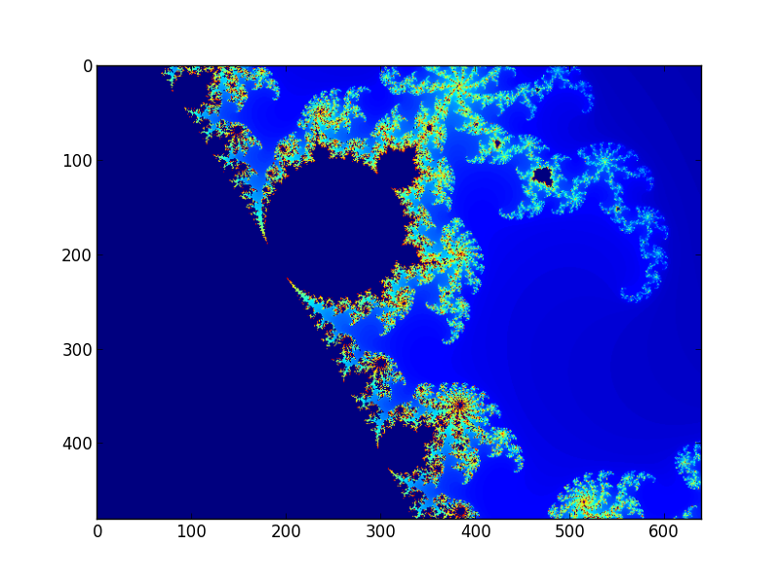

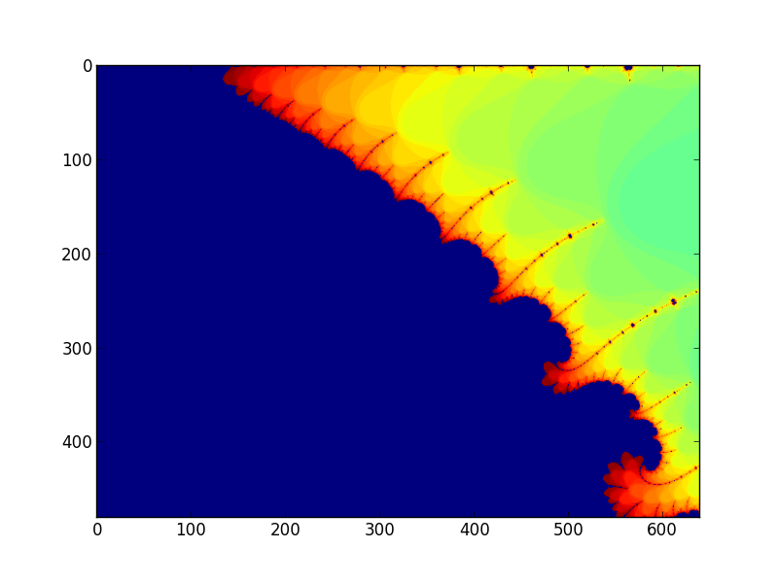

drawing_mandelbrot_test.v

/****************************************************************************************
* Author: Krzysztof Koch
* Brief: Stimulus file for functional testing of the line drawing module
* Date created: 17/11/2016
* Last edit: 26/11/2016
*
* Note:
****************************************************************************************/

/*------------------------------------------------------------------------------------------
* Definitions
*-----------------------------------------------------------------------------------------*/
`define CLOCK_PERIOD 20 // Clock period in time units
`define TEST_VECTORS 10 // Number of test vectors
`define VECTOR_LENGTH 7 // Test vector length
`define MAX_DELAY 3 // Maximum delay in clock cycles

/*--------------------------------------------------------------------------------------
* Global variables
*-------------------------------------------------------------------------------------*/
integer launch = 0; // Flag to indicate a test should be run
integer test_no = 0; // Test case counter
integer test_vectors; // File handle for input vectors
integer drawing_output; // File handle for saving drawing interface output
integer i;
integer delay; // Random delay for timing testing

// 2-D array to store the test vectors
reg [15:0] test_data [0:(`TEST_VECTORS - 1)][0:(`VECTOR_LENGTH - 1)];

/*--------------------------------------------------------------------------------------
* Load the test vectors from a file and open the file for saving debug data
*-------------------------------------------------------------------------------------*/
initial
begin
drawing_output = $fopen("/home/mbax4kk2/MandelbrotAccelerator/drawingOutput.txt","w");
test_vectors = $fopen("/home/mbax4kk2/MandelbrotAccelerator/testVectors.txt","r");
for (i = 0; i < `TEST_VECTORS; i = i + 1)
$fscanf(test_vectors, "%d %x %x %x %x %d %d", test_data[i][0], test_data[i][1],
test_data[i][2], test_data[i][3], test_data[i][4], test_data[i][5],
test_data[i][6]);
end

/*--------------------------------------------------------------------------------------
* Generate the clock signal and set initial values
*-------------------------------------------------------------------------------------*/
initial
begin
de_ack = 0;
clk = 0;
forever #(`CLOCK_PERIOD / 2) clk = ~clk;
end

/*--------------------------------------------------------------------------------------
* Task: insertDrawingCmd
* Purpose: Insert a command to the drawing module under test
* Inputs: Data parameters
*-------------------------------------------------------------------------------------*/
task insertDrawingCmd(input [15:0] arg0,
input [15:0] arg1,
input [15:0] arg2,
input [15:0] arg3,
input [15:0] arg4,
input [15:0] arg5,
input [15:0] arg6,
input [15:0] arg7);

begin
r0 = arg0; // Initialise the request to the drawing module under
r1 = arg1; // test by specifying the input parameters
r2 = arg2;
r3 = arg3;
r4 = arg4;
r5 = arg5;
r6 = arg6;
r7 = arg7;

launch = 1; // A request is ready to be triggerred

// Test case header
$fdisplay(drawing_output, "--------------------------------------------------------");
$fdisplay(drawing_output, "Maximum iterations:\t\t%4d", arg0);
$fdisplay(drawing_output, "Starting 'C' Real:\t\t%04x", arg1);
$fdisplay(drawing_output, "Starting 'C' Imaginary:\t%04x", arg2);
$fdisplay(drawing_output, "Step size: \t\t\t\t%04x%04x", arg3, arg4);
$fdisplay(drawing_output, "Screen width: \t\t\t%4d", arg5);
$fdisplay(drawing_output, "Screen height: \t\t\t%4d", arg6);
$fdisplay(drawing_output, "--------------------------------------------------------");
$fdisplay(drawing_output, "de_data\t\tde_addr\tde_nbyte");
end
endtask

/*--------------------------------------------------------------------------------------
* Command interface specificaton
*-------------------------------------------------------------------------------------*/
always @(posedge clk)
begin
// If the launch flag is raised, current request should be started (it is assumed that
// the parameters are already specified at this point
if(launch)
begin
// Introduce some random delays (multiples of clock period) to test timing
delay = ($urandom % `MAX_DELAY) * `CLOCK_PERIOD;
#delay
launch <= 0;
req <= 1;
end
// Clear the req signal if acknowledgement is received
else if(ack)
req <= 0;
end

/*--------------------------------------------------------------------------------------
* Drawing interface specificaton
*-------------------------------------------------------------------------------------*/
always @(posedge clk)
begin
// Clear the de_ack after a clock cycle
if(de_ack)
de_ack <= 0;
else if(de_req)
// Send the acknowledgement in response to the drawing request with some random
// delay
begin
delay = ($urandom % `MAX_DELAY) * `CLOCK_PERIOD;
#delay
de_ack <= 1;
end
end

/*--------------------------------------------------------------------------------------
* Runs tests one by one as soon as the previous test finishes
*-------------------------------------------------------------------------------------*/
always @ (negedge busy)
begin
if (test_no < `TEST_VECTORS)
begin
insertDrawingCmd(test_data[test_no][0], test_data[test_no][1], test_data[test_no][2],
test_data[test_no][3], test_data[test_no][4], test_data[test_no][5],
test_data[test_no][6], 16'hxxxx);
test_no = test_no + 1;
end
else
$stop;
end

/*--------------------------------------------------------------------------------------
* Dump the data from drawing interface for functional testing
*-------------------------------------------------------------------------------------*/
always @ (posedge de_ack)
begin
$fdisplay(drawing_output, "%x\t%x\t%x", de_data, de_addr, de_nbyte);
end

Fast model:

mandelbrot.py

"""
-------------------------------------------------------------------------------
Author: Krzysztof Koch
File: mandelbrot.py
Brief: Mandelbrot set visualisation fast model
Date created: 20.11.2016
Last mod: 26.11.2016

Notes:
-------------------------------------------------------------------------------
"""

# Include relevant libraries
import numpy as np
import sys
import re
import matplotlib.pyplot as plt

#------------------------------------------------------------------------------
# Constants and global variables
# -----------------------------------------------------------------------------
# Parameters for internal data representation
Q_LEN = 50 # Size of registers holding internal complex numbers
FRAC_LEN = 44 # Number of bits for fractional and integer in the complex
INT_LEN = Q_LEN - FRAC_LEN # number signed fixed-point representation. (sign bit included in INT)
INPUT_LEN = 16 # Input parameter size (in bits).
INPUT_INT_LEN = 4 # Number of bits for integer and fractional part of r1, r2
INPUT_FRAC_LEN = INPUT_LEN - INPUT_INT_LEN
PRE_MUL_SHIFT = FRAC_LEN / 2 # Pre-multiplication shift.
MASK = int("1" * Q_LEN, 2) # Bitmask for truncating multiplication output

#------------------------------------------------------------------------------
# Convert Q6.44 fixed point number to float
# -----------------------------------------------------------------------------
def q_to_float(number):

# Convert the number to binary string and test the msb (get rid of first two
# characters because they are "0b") Also bear in mind that leading zeros are not
# printed so length of the resulting string has to be tested too.
temp = bin(number)
temp = temp[2:]

# The number is negative (2s complement) so interpret it bit by bit.
if len(temp) == Q_LEN and temp[0] == '1':
accumulator = 0.0
for i in range(Q_LEN):
if temp[i] == '1':
if (i == 0):
accumulator -= 2 ** (INT_LEN - 1)
else:
accumulator += 2 ** (INT_LEN - 1 - i)

# Otherwise simple division will do.
else:
accumulator = number / float((2 ** FRAC_LEN))

return accumulator

#------------------------------------------------------------------------------
# Sign-shift the multiplication operands so that the output can be stored
# in registers of same size
# -----------------------------------------------------------------------------
def pre_mul_shift(number):

temp = bin(number);
temp = temp[2:]
temp = "0" * (Q_LEN - len(temp)) + temp
return int((temp[0] * PRE_MUL_SHIFT) + temp[0:Q_LEN-PRE_MUL_SHIFT], 2)

#------------------------------------------------------------------------------
# Convert the starting point coordinates from Q4.12 to Q6.44
# -----------------------------------------------------------------------------
def convert_start_coordinates(number):

temp = bin(number);
temp = temp[2:]
temp = "0" * (INPUT_LEN - len(temp)) + temp
return int(temp[0] * (INT_LEN - INPUT_INT_LEN) + temp + "0" * (FRAC_LEN-INPUT_FRAC_LEN), 2)

#------------------------------------------------------------------------------
# Mandelbrot - functional model of the mandelbrot set hardware accelerator
# (drawing_mandelbrot.v)
# -----------------------------------------------------------------------------
def mandelbrot(max_iterations, c_r, c_i, argand_step_h, argand_step_l, screen_width, screen_height):

# Test case header
modelOutput.write("--------------------------------------------------------\n")
modelOutput.write("Maximum iterations:\t\t{:4d}\n".format(max_iterations))
modelOutput.write("Starting 'C' Real:\t\t{:04x}\n".format(c_r))
modelOutput.write("Starting 'C' Imaginary:\t{:04x}\n".format(c_i))
modelOutput.write("Step size: \t\t\t\t{}{}\n".format(argand_step_h, argand_step_l))
modelOutput.write("Screen width: \t\t\t{:4d}\n".format(screen_width))
modelOutput.write("Screen height: \t\t\t{:4d}\n".format(screen_height))
modelOutput.write("--------------------------------------------------------\n")
modelOutput.write("de_data\t\tde_addr\tde_nbyte\n")

# Convert the input arguments to internal complex number signed fixed-point
# format
init_c_r = z_r = c_r = convert_start_coordinates(c_r)
z_i = c_i = convert_start_coordinates(c_i)
argand_step = int(argand_step_h + argand_step_l, 16)
argand_step = argand_step << (FRAC_LEN - 2 * INPUT_LEN)

# Initialise internal registers
bound = 4 << FRAC_LEN # Calculate the bound as a fixed-point fractional number
x_pos = 0 # Coordinates of the pixel currently being computed
y_pos = 0
iteration = 1 # Mandelbrot iteration counter. Set to 1 to save one cycle
# as we start with z_r = c_r and z_i = c_i instead of 0s

# Initialise the frame store
screen = np.zeros((screen_height, screen_width), dtype='uint8')

# Iterate through all the pixels on screen with specified parameter
while(True):

iteration = 1

# Mandelbrot iteration loop
while (iteration < max_iterations):

# Sign-shift current 'z' so that the output of multiplication can fit in registers
# of same size as input operands
mul_op1 = pre_mul_shift(z_r)
mul_op2 = pre_mul_shift(z_i)
z_real_sq = (mul_op1 * mul_op1) & MASK
z_imag_sq = (mul_op2 * mul_op2) & MASK

# Compute next value of 'z'
next_z_real = (z_real_sq - z_imag_sq + c_r) & MASK
next_z_imag = (((mul_op1 * mul_op2) << 1) + c_i) & MASK

# Compute the value of function and check if its still within bounds.
func_val = (z_real_sq + z_imag_sq) & MASK
if func_val > bound:
break

# Update the iteration counter and 'z'
iteration = iteration + 1
z_r = next_z_real
z_i = next_z_imag

# Write to frame buffer and dump the address and byte number and value to be written to
# to it. I want the inside of the fractal to be black
if iteration == max_iterations:
screen[y_pos][x_pos] = 0
else:
screen[y_pos][x_pos] = iteration & 0xFF

# Compute the pixel addres and byte number
de_data = screen[y_pos][x_pos]
address = (y_pos << 9) + (y_pos << 7) + x_pos
de_addr = address >> 2

# Byte select by low strobe
temp = address & 0b11
if (temp == 0):
de_nbyte = "e"
elif (temp == 1):
de_nbyte = "d"
elif (temp == 2):
de_nbyte = "b"
elif (temp == 3):
de_nbyte = "7"
else:
de_nbyte = "f"

# Print for functional testing against the verilog output
modelOutput.write("{0:02x}{0:02x}{0:02x}{0:02x}\t{1:05x}\t{2}\n".format(de_data, de_addr, de_nbyte))

# Compute the next pixel number coordinate and respective point in Argand plane
if (x_pos + 1 >= screen_width):
if (y_pos + 1 >= screen_height):
return screen
else:
x_pos = 0
y_pos = y_pos + 1
z_r = c_r = init_c_r
z_i = c_i = (c_i + argand_step) & MASK
else:
x_pos = x_pos + 1
z_r = c_r = (c_r + argand_step) & MASK
z_i = c_i

#------------------------------------------------------------------------------
# Main method
# -----------------------------------------------------------------------------
# File with test vectors
testVectors = open("testVectors.txt", "r")

# File with pixel values, addresses and byte numbers dumped.
modelOutput = open("modelOutput.txt", "w")

# Plotting figure counter
counter = 0

# Read the file with input vectors line by line
lines = testVectors.readlines()
for line in lines:
numbers = line.split(' ')
r0 = int(numbers[0]) # Max iterations before Mandelbrot set membership determined
r1 = int(numbers[1], 16) # Current real part of 'c'
r2 = int(numbers[2], 16) # Current imaginary part of 'c'
r3 = numbers[3] # Step size in Argand plane (32bit)
r4 = numbers[4]
r5 = int(numbers[5]) # Screen width
r6 = int(numbers[6]) # Screen height

# Launch the execution of command in module and show the resulting plot on virtual screen
screen = mandelbrot(r0, r1, r2, r3, r4, r5, r6)
plt.figure(counter)
plt.imshow(screen)
counter += 1

# Display all the figures generated
plt.show()

Synthesis report:

mandelbrot_logic

High-level logic constructs:
50x50-bit multiplier : 3
50-bit adder : 3
50-bit subtractor : 1
50-bit comparator greater : 1

Warnings worth mentioning:
WARNING:Xst:643 - "/home/mbax4kk2/Cadence/COMP32211/COMP32211/mandelbrot_logic/functional/verilog.v" line 73: The result of a 50x50-bit multiplication is partially used. Only the 50 least significant bits are used. If you are doing this on purpose, you may safely ignore this warning. Otherwise, make sure you are not losing information, leading to unexpected circuit behavior.

WARNING:Xst:643 - "/home/mbax4kk2/Cadence/COMP32211/COMP32211/mandelbrot_logic/functional/verilog.v"
line 74: The result of a 50x50-bit multiplication is partially used. Only the 50 least significant bits are used. If you are doing this on purpose, you may safely ignore this warning. Otherwise, make sure you are not losing information, leading to unexpected circuit behavior.

WARNING:Xst:643 - "/home/mbax4kk2/Cadence/COMP32211/COMP32211/mandelbrot_logic/functional/verilog.v"
line 78: The result of a 50x50-bit multiplication is partially used. Only the 50 least significant bits are used. If you are doing this on purpose, you may safely ignore this warning. Otherwise, make sure you are not losing information, leading to unexpected circuit behavior.

Device utilization summary:
Number of Slices: 981 out of 1920 51%
Number of 4 input LUTs: 1932 out of 3840 50%
Number of MULT18X18s: 6 out of 12 50%

drawing_manelbrot

High-level logic constructs:
4x4-bit ROM : 1
50x50-bit multiplier : 3
10-bit adder : 2
10-bit adder carry out : 2
16-bit adder : 1
20-bit adder : 2
50-bit adder : 5
50-bit subtractor : 1
1-bit register : 1
10-bit register : 4
16-bit register : 2
50-bit register : 6
11-bit comparator greatequal : 4
16-bit comparator equal : 1
16-bit comparator greatequal : 1
50-bit comparator greater : 1

FSM:
-------------------
State | Encoding
-------------------
00 | 00
10 | 10
01 | 01
-------------------

Device utilization summary:
Number of Slices: 1276 out of 1920 66%
Number of Slice Flip Flops: 332 out of 3840 8%
Number of 4 input LUTs: 2472 out of 3840 64%
Number of MULT18X18s: 6 out of 12 50%

Timing Summary:
Speed Grade: -4
Minimum period: 29.496ns (Maximum Frequency: 33.903MHz)
Minimum input arrival time before clock: 7.412ns
Maximum output required time after clock: 25.937ns
Maximum combinational path delay: No path found

Test coverage summary:

mandelbrot_logic

Test coverage - top:
block: 100%
expression ---
toggle 91%

Comment:
It is difficult to exercise all bits in each operand if these are 50 bits wide. This is a strictly combinatorial logic module so there are no control signals except the input parameters. There are no expressions in test coverage and the block is fully tested.

drawing_mandelbrot

FSM Coverage: 100%
Test Coverage: 73%

Top:
block: 91%
expression 100%
toggle 65%

Comment:
The blocks uncovered are default cases that are there only to trap irregular behaviour and in a correctly functioning module they should never be executed. These tests take very long to run, again 50-bit internal complex number representation, thus, it is impossible to toggle all the bits.

Ex3

Interface specification

Argument | # bits | Function | Example
r0 | 16 | Maximum number of iterations per pixel | 20
r1 | 16 (Q4.12) | Starting 'real' part of 'c' in the Mandelbrot complex recurrence equation z^2 + c. Controls the starting point in the X axis for which mandelbrot set is visualised. Signed fixed point number:  sign bit | 3 integer bits | 12 fractional bits. | 0xF800  (-0.5)
r2 | 16 (Q4.12) | Starting 'imaginary' part of 'c' in the Mandelbrot complex recurrence equation z^2 + c. Controls the starting point in the Y axis for which mandelbrot set is visualised. Signed fixed point number:  sign bit | 3 integer bits | 12 fractional bits. | 0x1400  (1.25)
r3 | 32 (Q0.32) | Step size in Argand plane. 32 bit long, always positive | 0x20000000  (0.125)
r4 | 32 (Q0.32) | Step size in Argand plane. 32 bit long, always positive | 0x20000000  (0.125)
r5 | 16 | Screen width (in pixels) | 640
r6 | 16 | Screen height (in pixels) | 480
r7 | - | - | -

Schematic with unit in place:
